/*Ashok IPBC SQL Practice lab 7.14.19*/

1. How many are active from each group. Return the answers in one query and put the results in a

table variable.

a. Paths b. Courses c. Sections d. Events

2. How many documents have been created but not attached to the Curriculum.

3. How many active events are there in each Course? Sort from largest to smallest

4. Create a View that outlines the whole curriculum in the correct order.

5. How many of each Event Type’s are included in the Active Curriculum.

6. Create a SP that accepts CourseID as a parameter and returns SectionName, DocumentName and

EventType’s stored in the Course passed into the SP.

7. Create INSERT Statements to add 1 record into each of the 6 tables.

8. Create UPDATE Statements for each table (Except ADF_EventType) to mark one Active record from each table as Inactive.

**Separately attached SQL query file for above questions in ZIP folder.**

-----------------------------------------------------------------------------------------------------------------------------------------

What to Submit:

1. Copy and paste the link to your video(s) as part of your homework.

<https://app.colaberry.com/app/ipbc/videos?user=31221&category=25>

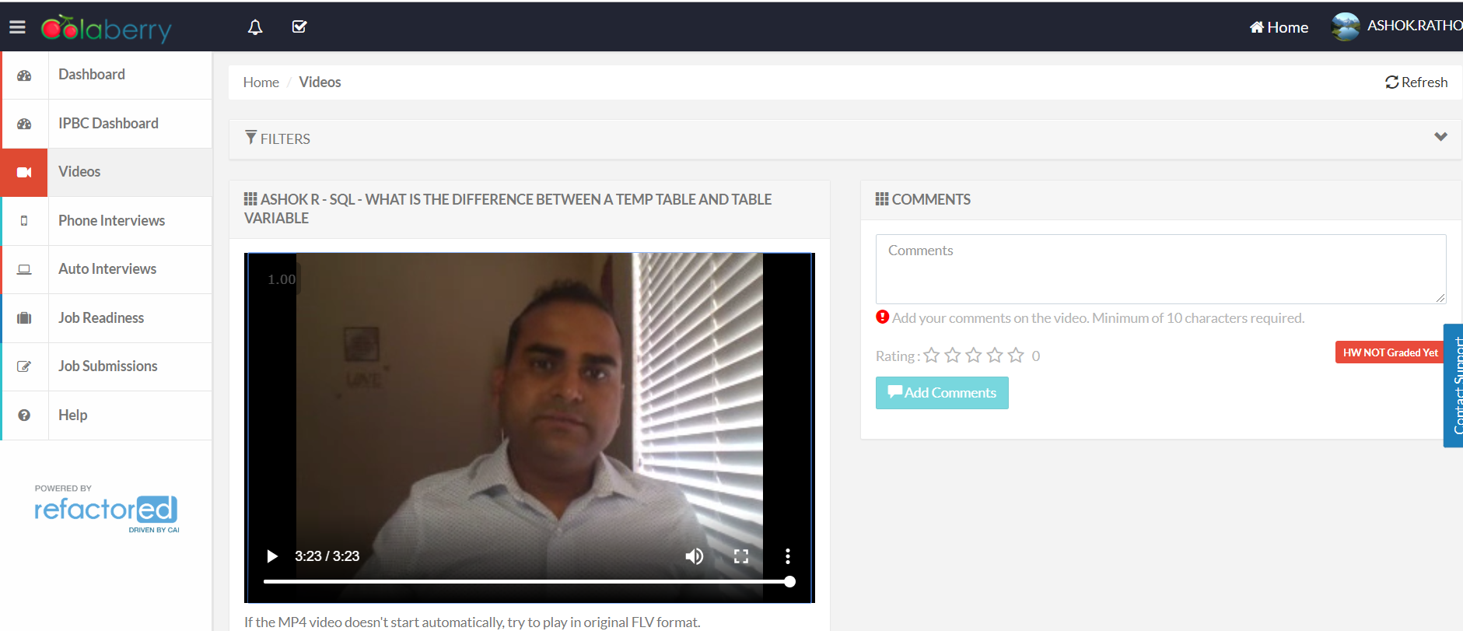

2. Watch, Comment &amp; take screenshots of your comments from 3 other videos on the same topic (per question). Comments must be 20+ characters. Leave comments based on presentation, delivery and/or technical details. Your critiques will help you be more conscious of your own videos. (3 comment screenshots per Video Question)

